# How to Create A Proper Rmarkdown Document

# 

1. To give a short, concise name



1. To use one of the themes:
2. “cerulean”

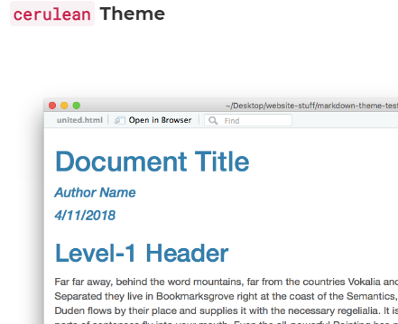

1. “tactile” (prettydoc)

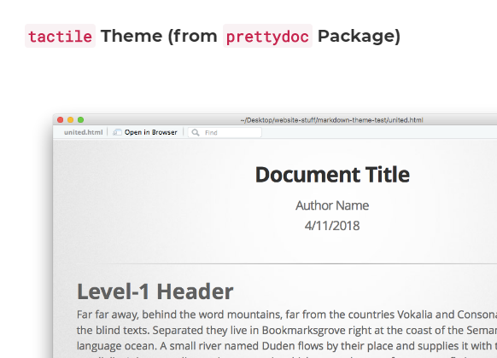

1. “readthedown“(rmdformats)

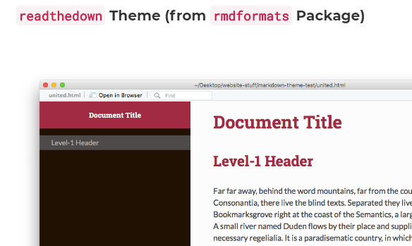

1. “tintHtml” (tint)

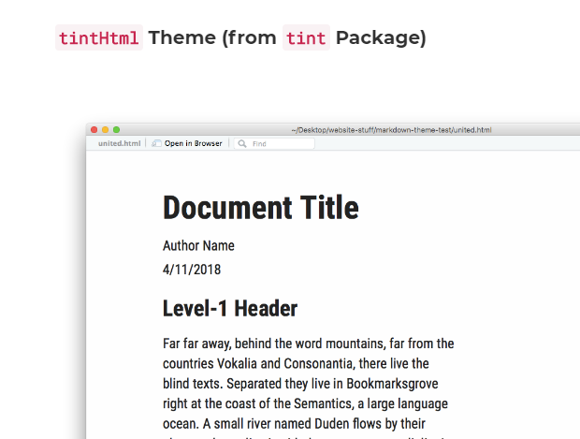

1. To use toc (table of contents)

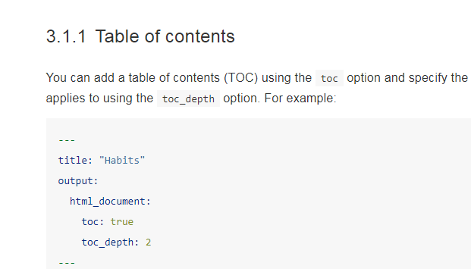

1. To provide a link to the original date used in the analysis



1. Provide a link to the files used in the analysis



1. Show 1 step: Getting and Preparing the Data

